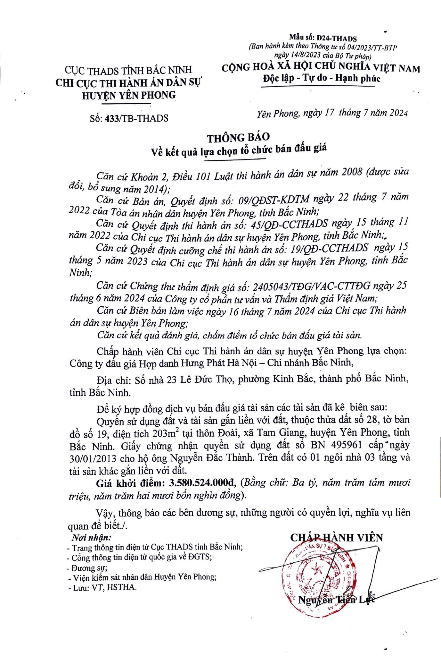**Miu s6: D24-THADS**

*(Ban hanh kem theo Th6ng tu s& 041202 JITT-IJTP*

*ngay 14/8/2023 cua 89 Tu phap)*

Cl)C THADS TiNI-I BAC NINH **C()NG HOA XA H0I CHU NGHiA VItT NAM**

CHI eve THI HANH AN DAN sv **f>qc ljp** -***Tv* do** - **lifnh phuc**

HUYtN YEN PHONG

S6: 433/TB-THADS *Yen Phong, ngay 17 thang* 7 *niim 2024*

,. ,

# THON G BAO

**V~ k't qua h1a ch9n t6 chuc ban diu gia**

. *~an cu Khoan 2, DiJu 101 Lut)t thi hanh an dan S'J! niim 2008 (du(JC sua doi, b6 sung niim 2014);*

*Can cu Ban an, Quyit dinh s6: 09/QDST-K.DTM ngay 22 thang* 7 *niim*

*2022 cua Toa an nhan dan huy?n Yen Phong, tlnh Bdc Ninh;*

., *Can cu Quyit dinh thi hanh an s6: 45/QD-CCTHADS ngay, 15 thang 11 nam 2022 cua Chi* qte *Thi hanh an dan s11 huy?n Yen Phong, tinh Biic Ninh,~*

, *Can __ cu Quyit dinh cufmg chi thi hanh an s6: 19/QD-CCTHADS ngay 1,5 thang 5 nam 2023 cua Chi CUC Thi hanh an dan SU* • *hu,1en* ..,, • • *Yen Phonu,* 0 ' *tinh Bae*

*Ninh· ,* • •

*Can cu Chung thu thdm dinh gia s6: 2405043/TDG/VAC-CITDG ngay 25 thang 6 nam 2024 cua Cong ty c6 phdn tu vdn va Thizm dinh gia Viit Nam;*

*Can cu Bien ban lam Vi?C ngay 16 thang* 7 *nam 2024 cua Chi Cl:IC Thi hanh an dan Sf! huyfn Yen Phong;*

*Can cu kit qua tlanh gia, chdm aidm t6 chuc ban adu gia tai scin.*

Chftp hanh vien Chi e\}e Thi hanh an dan S\f huyen ~en Phong lga chQn:

Cong ty dau gia Hgp danh Hung Phat Ha N9i - Chi nhanh Bae Ninh,

Dja chi: S3 nha 23 Le Due Th<;>, phuong Kinh Bie, thanh ph3 B~c Ninh, tinh Bile Ninh.

DS ky hgp d6ng djch V\l ban dftu gia tai san cac tai san da ke bien sau:

QuySn sir d1=1ng d§.t va tai san gful liSn v&i d§.t, thu(k thira d~t s6 28, to ban df> s6 19, di~n tich 203m2 t~i thon Doai, xa Tam Giang, huy~n Yen Phong, tinh Bile Ninh. Gifty chung • nh~ quySn sir d\lllg dit s6 BN 495961 cip • ngay 30/01/2013 cho h(> ong NguySn Bile Thanh. Tren ddt c6 01 ngoi nha 03 t~ng va tai san khac gful liSn v6i dit.

**Gia khoi di~m: 3.580.524.000d,** *(Bang chu: Ba ty, nam tram tam muai tri¢u, nam tram hai muai b6n nghin d6ng).*

V~y, thong bao cac ben ducmg SlJ, nhfrng nguoi c6 quySn lc;ri, ngh'ia v1=1 lien